**INTRODUCTION TO**

**C++**

**LAB # 1**



**Spring 2022**

**CSE102L Computer Programming Lab**

Submitted by: **Ali Asghar**

Registration No. : **21PWCSE2059**

Class Section: **C**

“On my honor, as student of University of Engineering and Technology, I have neither given nor received unauthorized assistance on this academic work.”

Student Signature: ______________

Submitted to:

**Engr. Abdullah Hamid**

July 4, 2022

Department of Computer Systems Engineering

University of Engineering and Technology, Peshawar

**Lab Objective(s)**

* To be able to install and use Dev C++ IDE for compiling C++ programs
* To be familiar with syntax and structure of C++ programming

**TASK #1:**

**Title:**

Write a program to display your name on console.

## CODE SCREENSHOTS:

Here is the screenshot of the code.

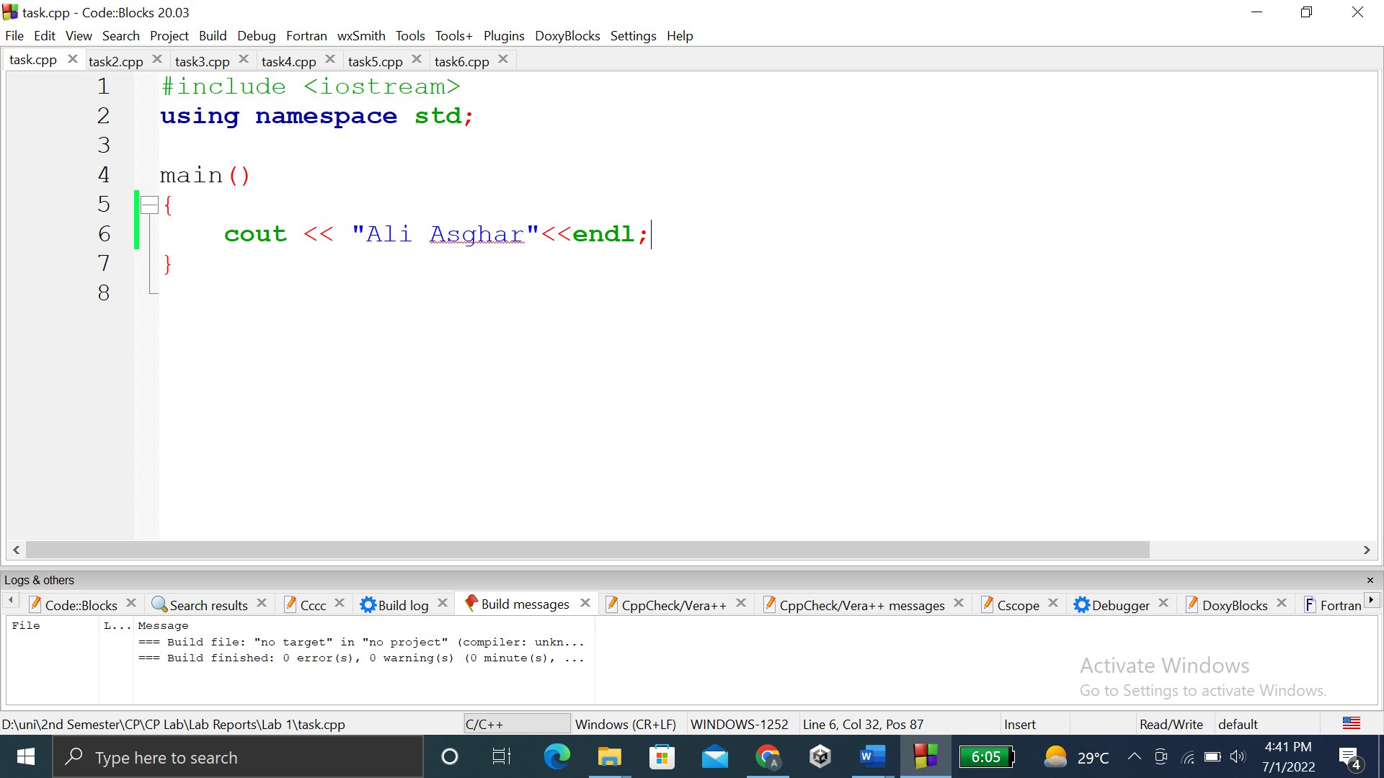

### **OUTPUT (COMPILATION, DEBUGGING & TESTING):**

Here is the screenshot of the output of above code.

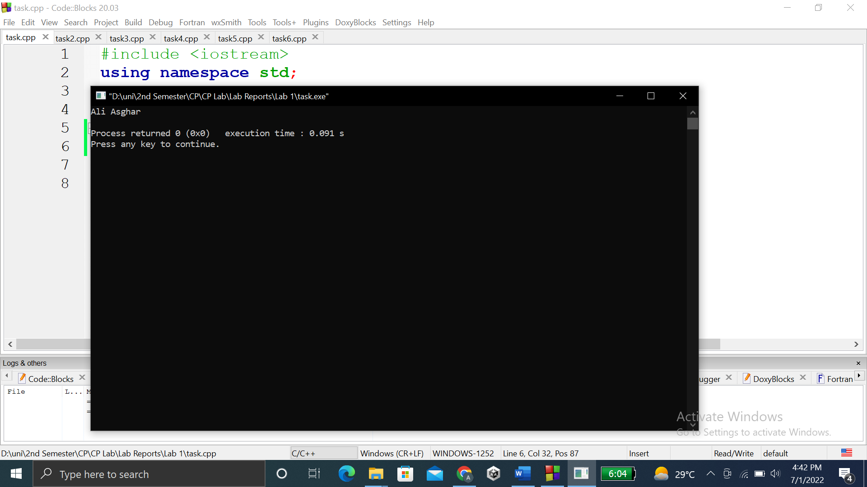

**TASK # 2:**

**Title:**

Write a program to add two numbers (6+3=) and display its sum.

## CODE SCREENSHOTS:

Here is the screenshot of the code.

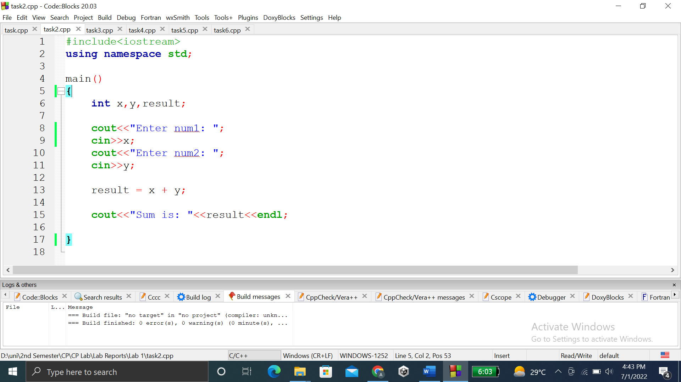

### **OUTPUT (COMPILATION, DEBUGGING & TESTING):**

Here is the screenshot of the output of above code.

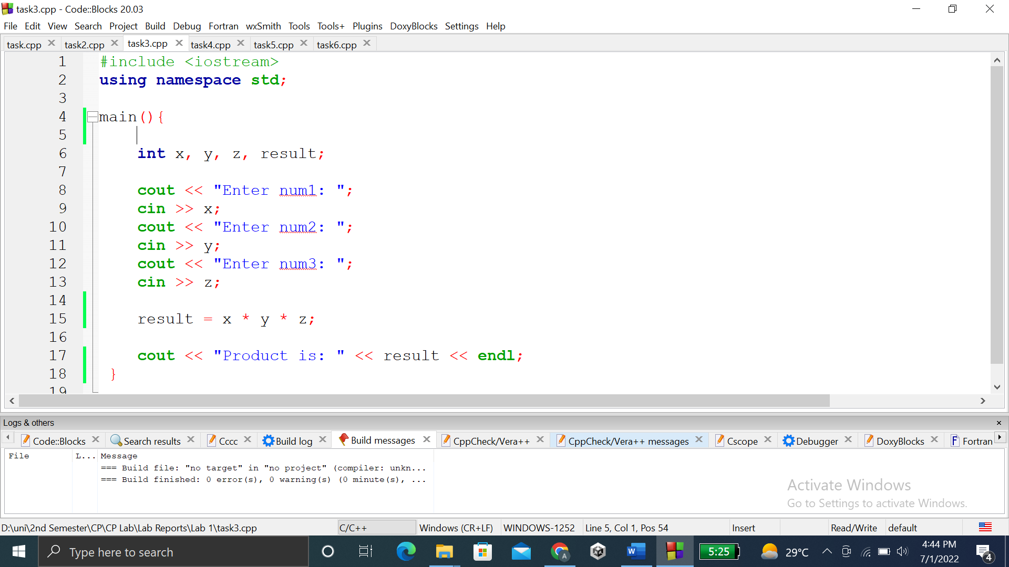

**TASK # 3:**

**Title:**

Write a program to multiply three numbers (5x5x5=) and display its product.

## CODE SCREENSHOTS:

Here is the screenshot of the code.

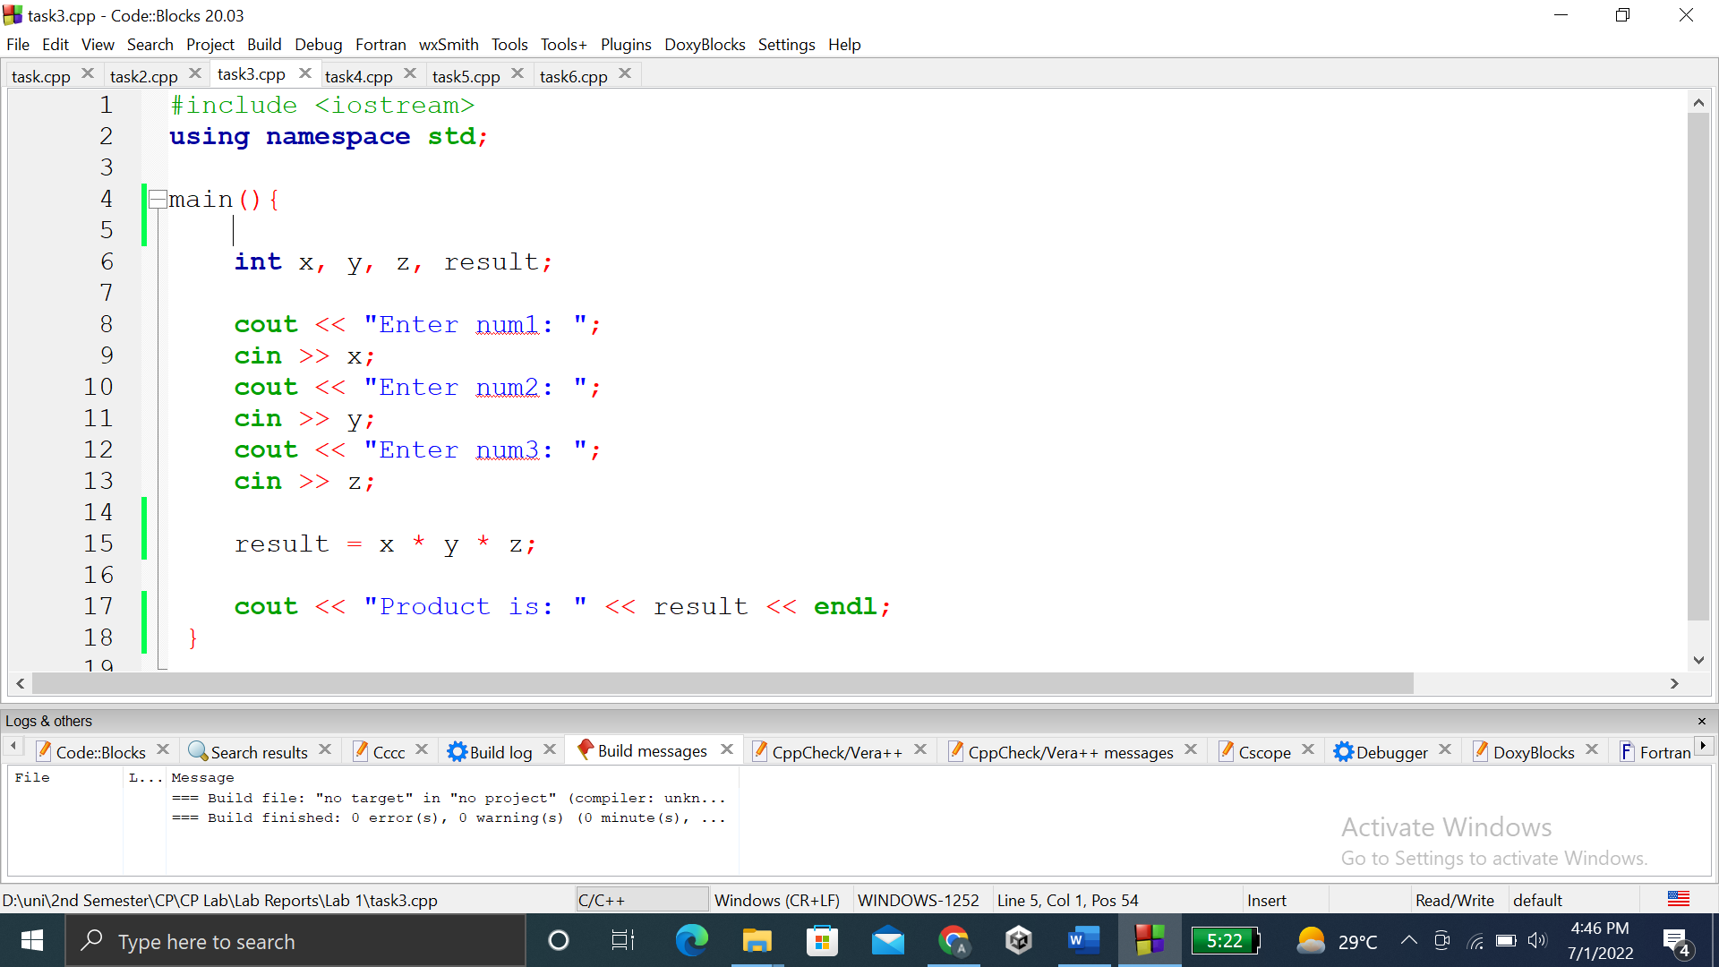

### **OUTPUT (COMPILATION, DEBUGGING & TESTING):**

Here is the screenshot of the output of above code.

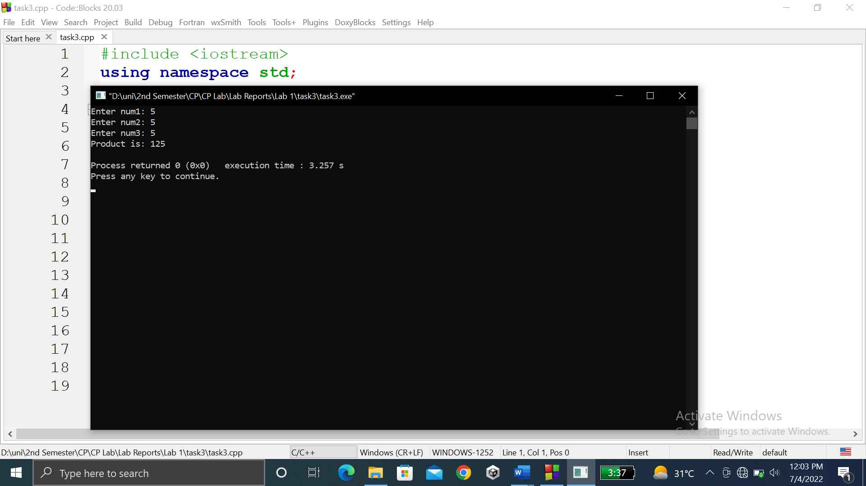

**TASK # 4:**

**Title:**

Write a program to find the mod of (5%2=) and (6%2=)

## CODE SCREENSHOTS:

Here is the screenshot of the code.

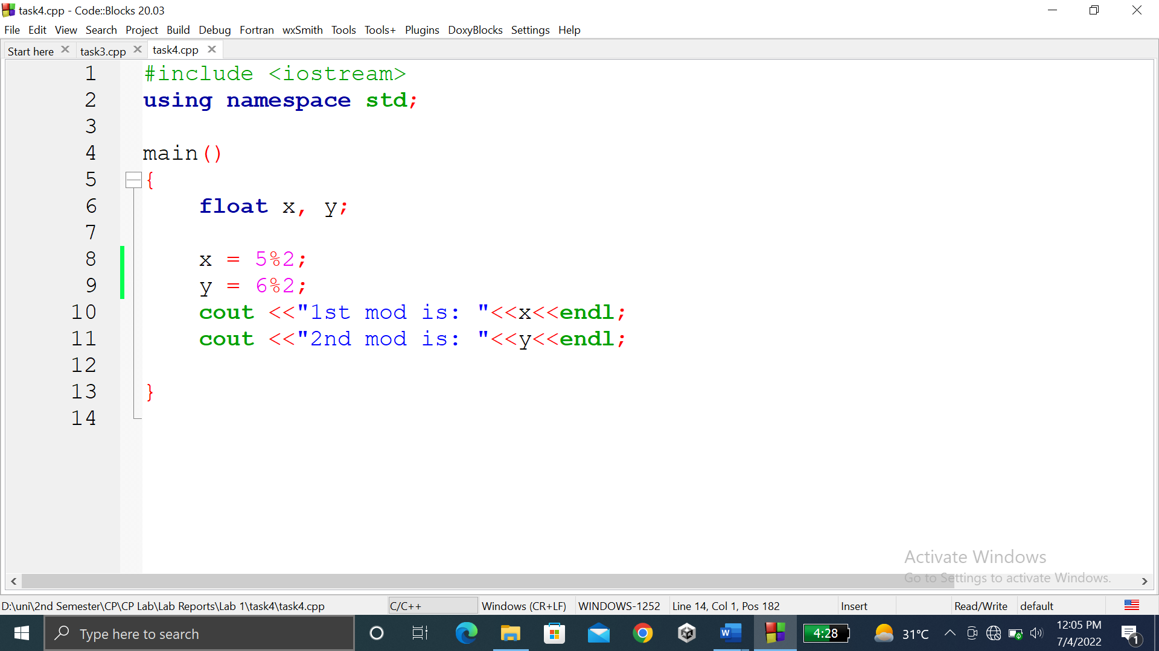

### **OUTPUT (COMPILATION, DEBUGGING & TESTING):**

Here is the screenshot of the output of above code.

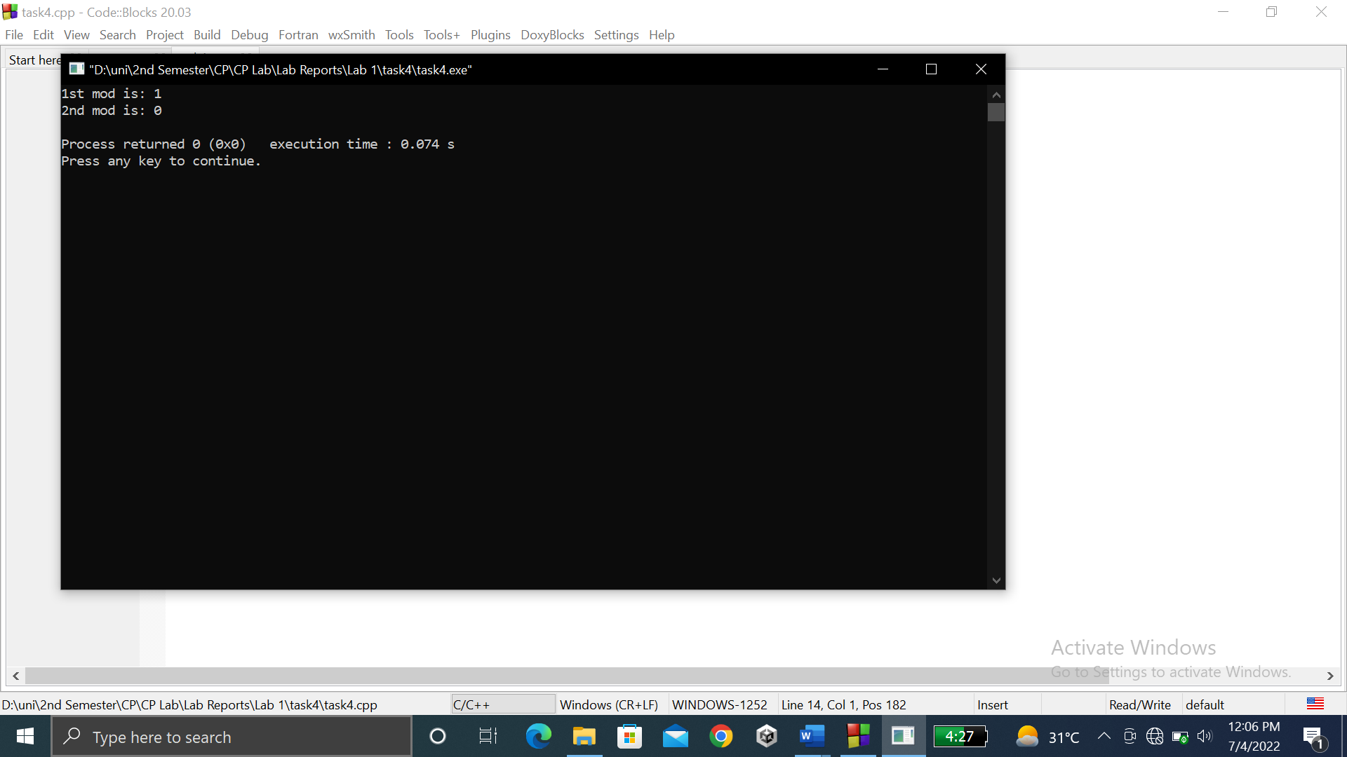

**TASK # 5:**

**Title:**

Write a program to calculate area of a circle having its radius (ask user to input radius).

## CODE SCREENSHOTS:

Here is the screenshot of the code.

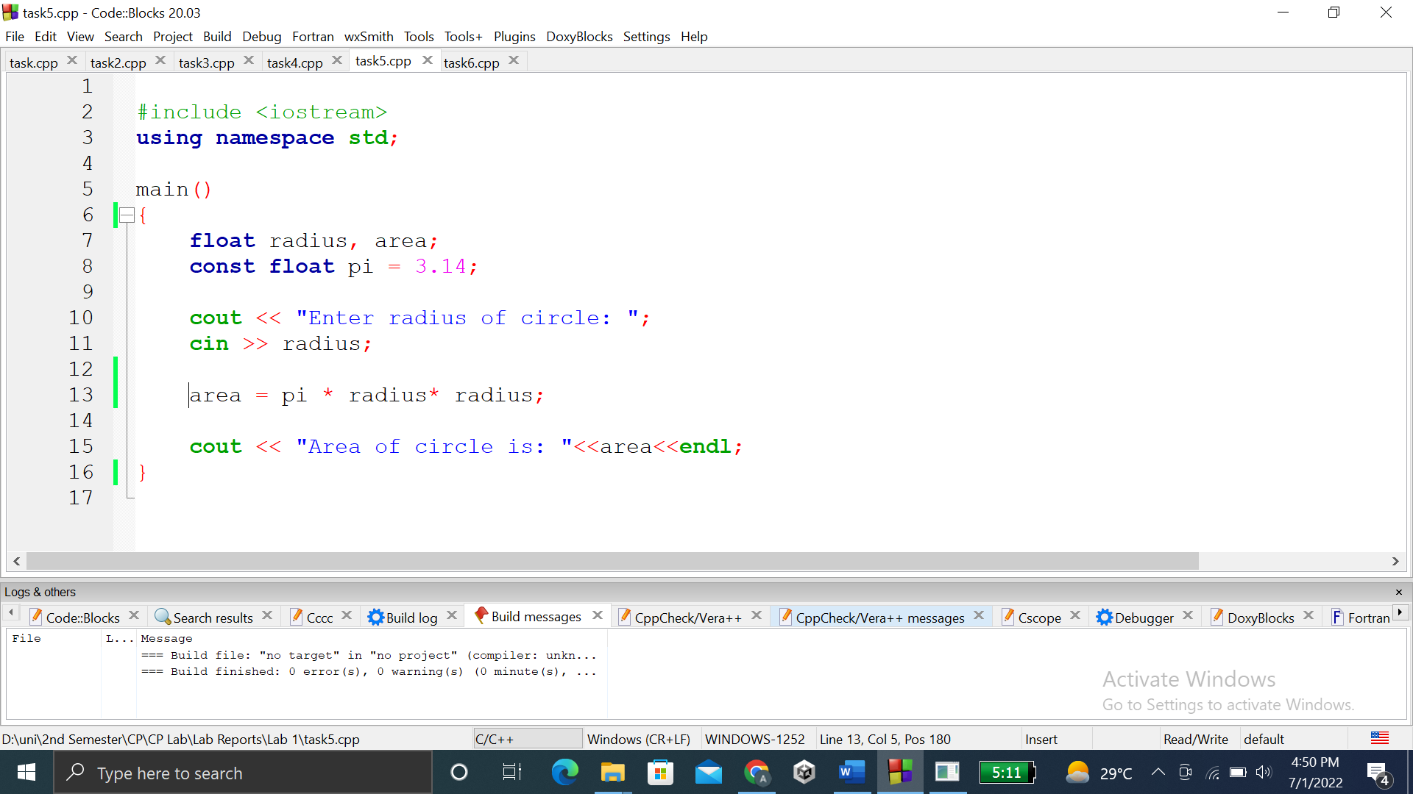

### **OUTPUT (COMPILATION, DEBUGGING & TESTING):**

Here is the screenshot of the output of above code.

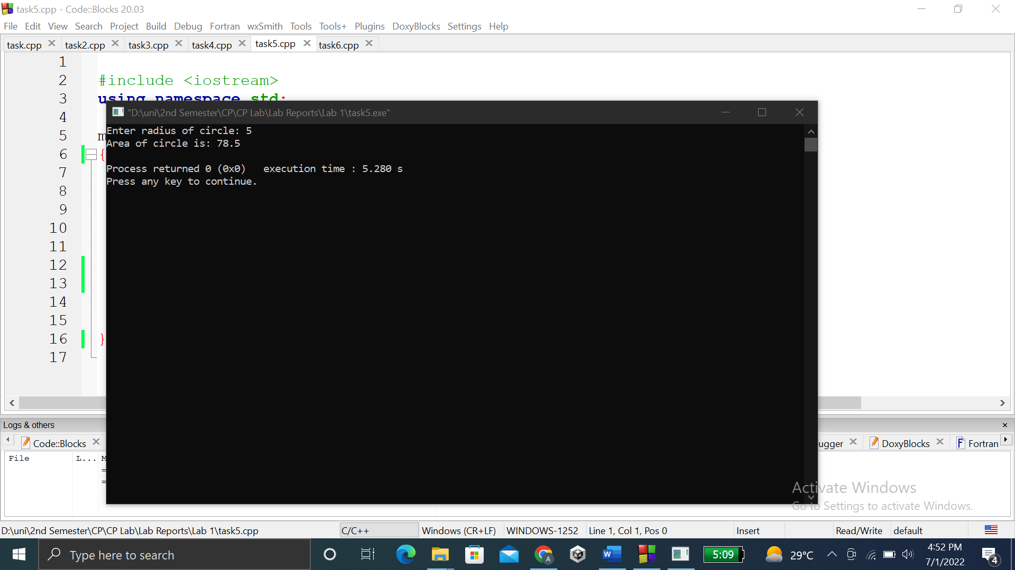

**TASK # 6:**

**Title:**

Write a program to calculate area of an ellipse having its axes (ask user to input values of major, minor)

## CODE SCREENSHOTS:

Here is the screenshot of the code.

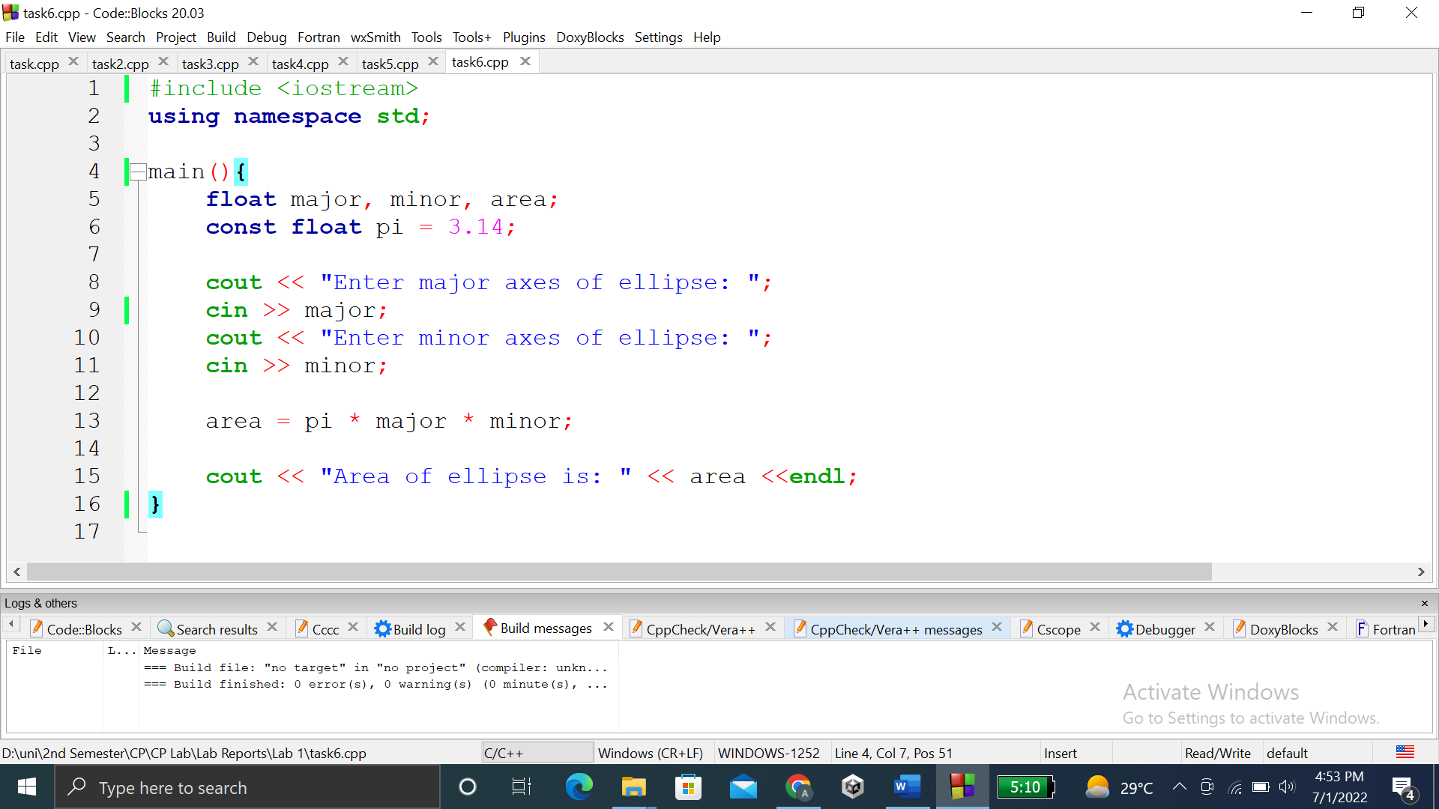

### **OUTPUT (COMPILATION, DEBUGGING & TESTING):**

Here is the screenshot of the output of above code.

